

LEARNING MEDIA DESIGN FOR INTRODUCTION TO FAMILY SACRED PLACES (SANGGAH)

I Komang Putra Wibawa¹, I Wayan Adi Putra Yasa², Putu Surya Wedra Lesmana³
^{1,2,3}Program Studi Teknik Informatika, Fakultas Teknologi Dan Informatika, Institut Bisnis Dan Teknologi Indonesia, Denpasar, Indonesia
Email: ¹komangputra555@gmail.com, ²adipyasa@instiki.ac.id, ³suryawedra@instiki.ac.id

Received on  21 February 2025 | Revised on  20 March 2025 | Accepted on  22 March 2025

Abstract :
Purpose : The development of information technology in the modern era has brought changes to society in various aspects of life, including education. In this digital era, Hindu religious education in Indonesia has also begun to adopt modern technology. However, a survey conducted among teenagers or STT (Islamic boarding school) in Banjar Bunyuh, Perean Village, Baturiti, Tabanan, found that they are still unfamiliar with religious knowledge, such as the family shrine or sanggah pemerajan (Islamic boarding school). To address this lack of knowledge, more modern and engaging learning media, such as Android-based interactive multimedia, are needed.
Research methods : The method used is a three-stage production process: pre-production, production, and post-production. Primary data was obtained through interviews, observations, and surveys, while secondary data was obtained through library sources relevant to the research and documentation.
Findings : The results of the interactive multimedia design obtained results that met the established criteria, respondents considered that this interactive learning media could quickly understand the form and function of each pelinggih, as well as develop better reading and writing skills.
Implications : In the future, this multimedia development can be further developed by adding more information and video media in it so that it can further increase public insight.

Keywords : android, learning media, sanggah merajan.

INTRODUCTION
Sekaa Teruna Teruni (STT) is an organization that serves as a forum for developing the younger generation, especially school-aged and out-of-school children, to explore and apply the importance of socializing in Balinese society. Its members are teenagers from the banjar who are of age, ranging from 15 years old to unmarried[1]. The STT organization plays a role in supporting various local activities and strengthening bonds among teenagers. Being in a social environment, teenagers are inextricably linked with peers and possess a strong sense of curiosity. The existence of the STT organization in Bali serves as a platform for teenagers to develop their insights, develop their potential, and pursue positive hobbies by holding various activities involving STT teenagers[2]. In Bali, one of the holy places for prayer is called a merajan or sanggah in Hindu families. It is a holy place based on the concept of Tri Mandala, Tri Angga, or Tri Hita Karana, which serves as a place to worship both God and ancestors. [3] The Merajan consists of the main shrines, namely Kamulan, Padmasana, Taksu, Gedong, and Rong Tiga. The Sanggah is a sacred place for families in a courtyard, and has various names, such as mrajan, sanggah merajan, penghulun karang, sanggar kamimitan, sanggah kemulan, or sanggah pemerajan. The existence of the Sanggah is a building that still holds artistic and cultural values.
However, the meaning of merajan, especially among Bali's younger generation, remains elusive. A survey of teenagers and religious leaders (STT) in Banjar Bunyuh, Perean Village, Baturiti, Tabanan, found that the younger generation is still unfamiliar with religious knowledge, such as the family shrine or sanggah pemerajan. They still accept and carry out religious activities, but lack a clear understanding of the significance of these structures. Therefore, efforts are needed to improve the understanding of today's young Balinese generation. One way to achieve this is by combining culture and art with technology. Technological developments in education have brought significant changes to the learning process. In this technological era, the younger generation is starting to forget their traditional cultural heritage due to the lack of modern and engaging cultural learning media. Traditional cultural learning media are limited to books and other printed media. Therefore, more modern learning media, such as interactive multimedia, are needed to facilitate student learning compared to monotonous textbooks or e-books[4][5].
The use of interactive multimedia as a learning medium in the teaching and learning process is currently quite widely developed and used. This is because it contains various elements, such as images, audio, video, interactivity, and animation, which help improve memory and convey information[6], [7]. In addition, the use of learning media is very important because it can be done directly in various places and times, and the learning process will be more interesting and flexible.[8]. Similar developments have also been developed with the case object of the Dalem Blanjong temple, Kesiman, which produced interactive multimedia about the history of the temple, the location of the temple, a photo gallery of the buildings/pelinggih, as well as the differences in names and descriptions of each pelinggih[9]. Therefore, the development of interactive media to introduce family rituals based on Android is highly feasible. This interactive media is expected to increase students' interest in Android-based family rituals through more engaging visualizations.

RESEARCH METHODS
This research is related to the collection of related and relevant data regarding the design of learning media for introducing family sacred places (sanggah). The data used are primary and secondary data. Primary data was obtained through interviews with related informants, namely Wahyu Adnyana, as the first deputy chairman of STT. Direct field observations were also conducted to find out more problems with adolescents in the banjar. Secondary data was also used to support the research obtained from documentation and literature studies of relevant data to support the research. In the process of designing learning media, it was carried out through three stages: pre-production, production, and post-production[10]. The results of the learning media will later be tested and distributed to target audiences.

FINDINGS
The design of learning media for introducing the family's sacred place begins with 3 stages, namely;
Pre-production
Pre-production is the initial stage of planning and data collection or reference work in the design process, including compiling and collecting important assets that can support the interactive multimedia design process. In this research, the author used a computer with appropriate specifications, such as a laptop and a mobile phone, for the production process and preparation of other necessary assets. The software used in creating the learning media included CorelDRAW for creating visual assets and Adobe Animate for creating interactive multimedia learning applications.
The next step is to determine the design concept used, namely simplicity. This learning media is designed to provide a comprehensive introduction to building drawings, development through easily accessible interactive content, and provide additional content and support for teachers or parents to support optimal understanding. The concept is further implemented through supporting elements such as typography, color, and audio. The typography used is Serif and Sans Serif, which have a simple form and are easy to read. These typefaces are suitable for the design of this interactive media that uses the concept of simplicity. The colors used are colors related to nature, dominated by blue and green, to convey a neutral impression to create a relaxing atmosphere, as well as several other supporting colors. Meanwhile, the audio or sound element uses a Balinese gamelan instrument in WAV format. After that, the learning media menu structure is compiled as illustrated below.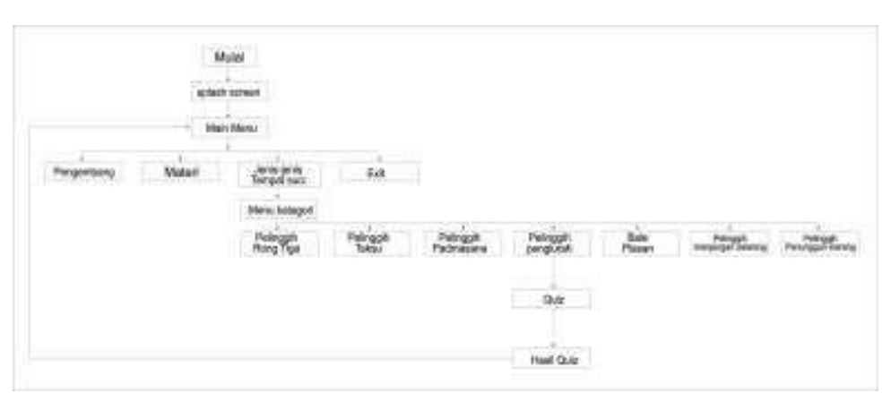
Figure 1 . Multimedia menu navigation
[Source: Writer, 2025]

Production
The production process involves several stages, including creating image assets, animating, and adding background music. The process begins with asset creation using vector image processing software to process and edit the designs or vector images that form the basis of this interactive multimedia. The user interface is essential in this process, as the assets created are based on the pre-designed user interface. The design process begins with creating an outline and then adding color. An example of asset creation is illustrated by creating a pelinggih building asset, starting with the outline as a base. The outline creation process uses freehand tools and shapes. The tools used in this process include the 3-point curve, rectangle tool, ellipse, ruler, and layers. The Merajan building is then colored with a light brown color to match the natural hues.
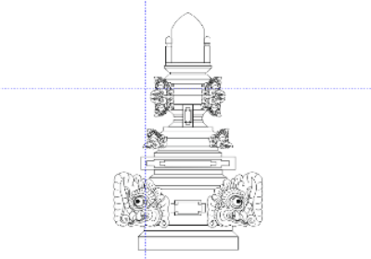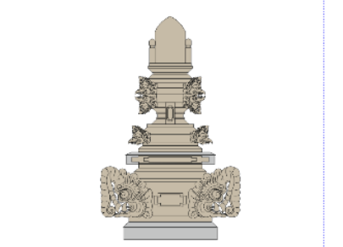
Figure 2 Creating vector assets
[Source: Writer, 2025]

The next step after asset creation is the animation process. The animation process is performed using animation processing software. The created character assets will be animated according to the designed user interface. This process begins by combining character assets, props, and backgrounds into a single layout in Adobe Animate.

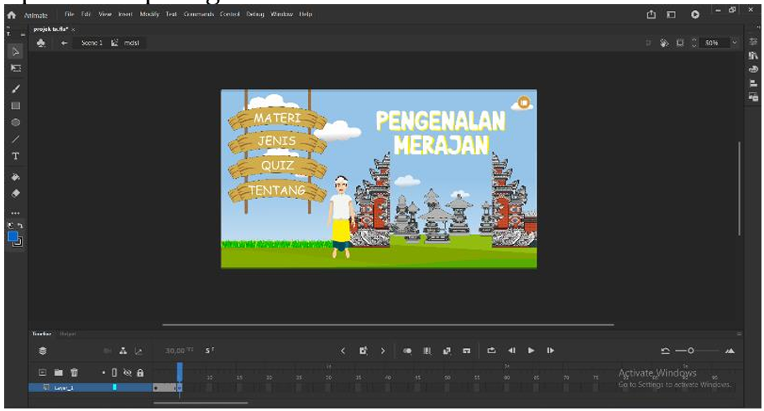
Figure 3 Adding assets to Adobe Animate
[Source: Writer, 2025]

Once all the necessary assets are in one layout, the animation process can begin. First, shift the timeline to frame 1. Then, begin moving the assets according to the designed user interface. The animation process is carried out by adding key frames from frame to frame. Once the animation process is complete, the next step is to create commands/coding to access the menus so they function properly.
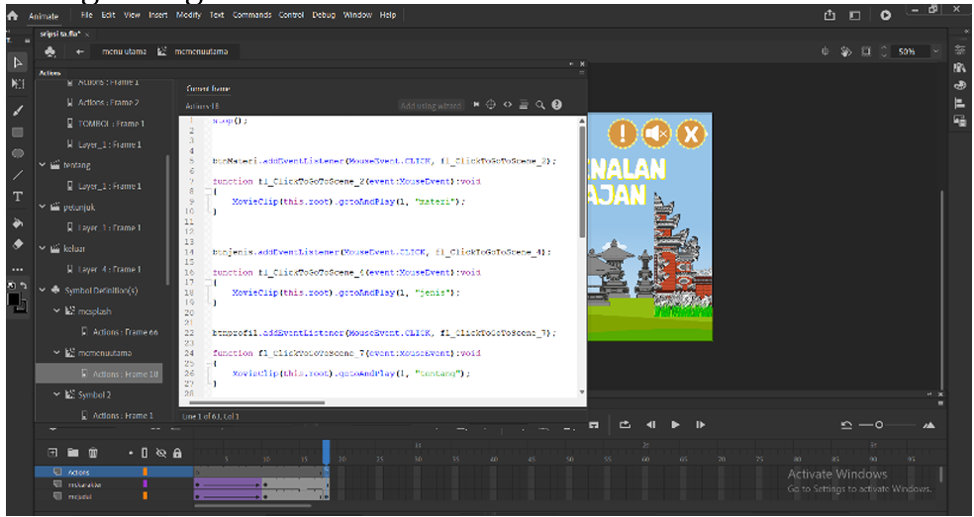
Figure 4 Giving command script
[Source: Writer, 2025]

Once the assets have been added, the next step is to add background sound. There are several ways to add background sound in Adobe. The process for adding background sound in this application uses an ActionScript. The music format used must be (.MP3), and the music file must be saved in the same folder as the media file (.SWF).

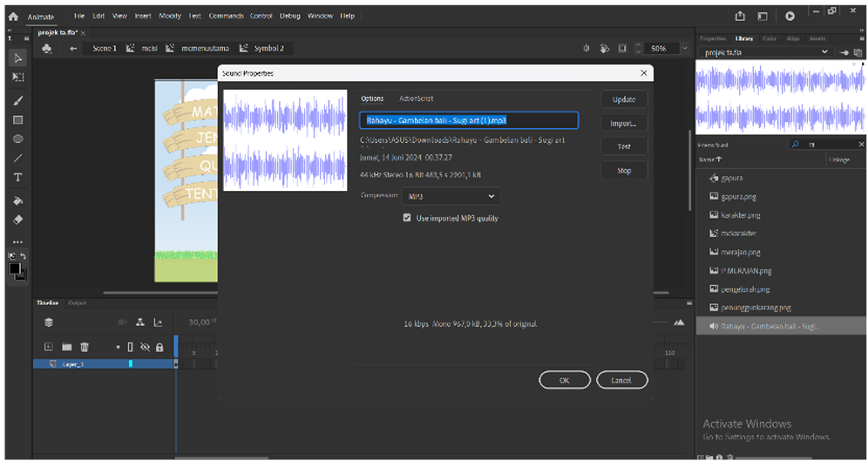
Figure 5 Menambahkan backsound
[Source: Writer, 2025]

Post-production
Post-production occurs after the production process is complete. This stage includes combining all animated scenes, adding background music, creating SFX, editing, and final rendering. The following are the processes involved in the post-production stage.

Table 1 Visualisasi Menu multimedia pembelajaran
[Source: Writer, 2025]

No. | Visualization | Information
1 | 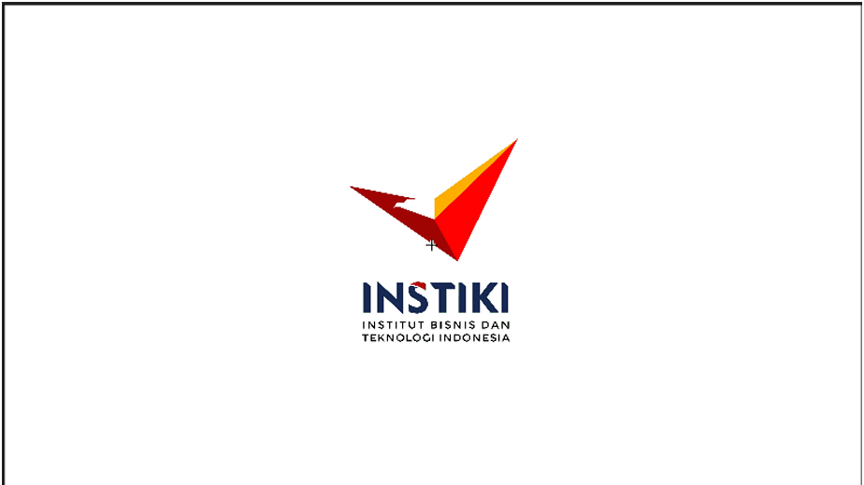 | The splash screen displays the logo and title of the interactive media from the application.
2 | 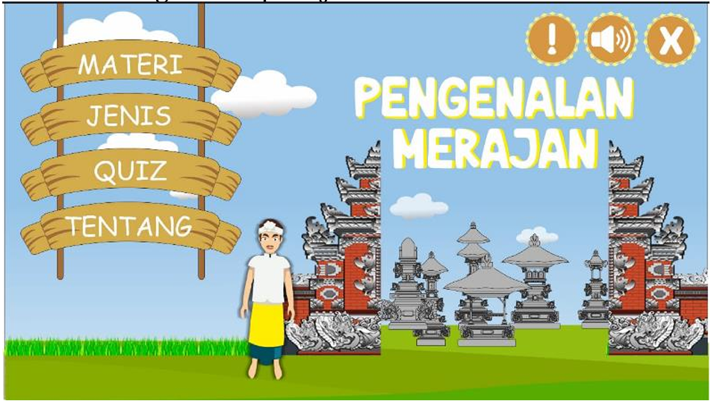 | The main menu contains several buttons that can be accessed, namely: material button, type button, quiz button, about button, sound, instructions and exit button.
3 | 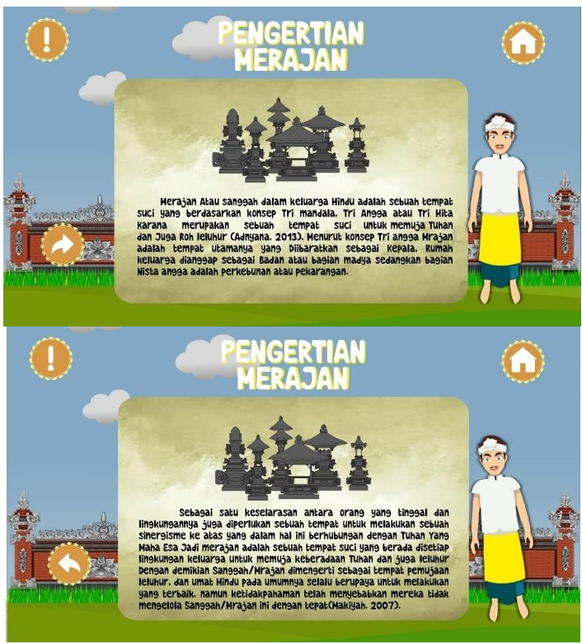 | This material menu displays a brief explanation regarding the pelinggih and contains a next button to go to the next page.
4 | 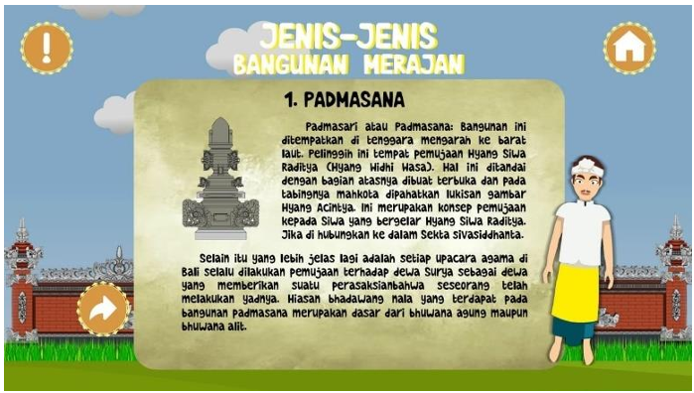 | This menu of types of shrines displays the types of shrines and a brief explanation of the shrines and contains a next button to go to the next page.
5 | 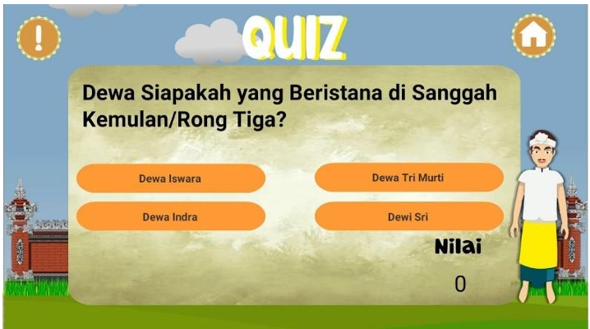 | Quiz menu display showing multiple choice questions
6 | 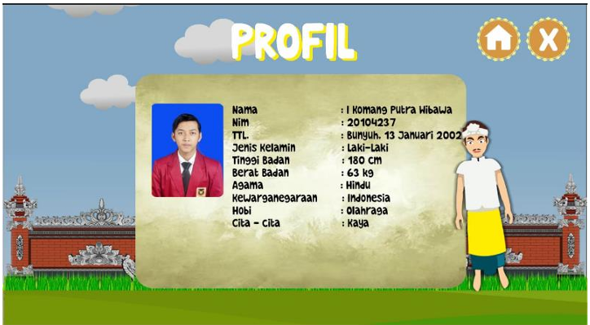 | Display of the learning media creator profile menu
7 | 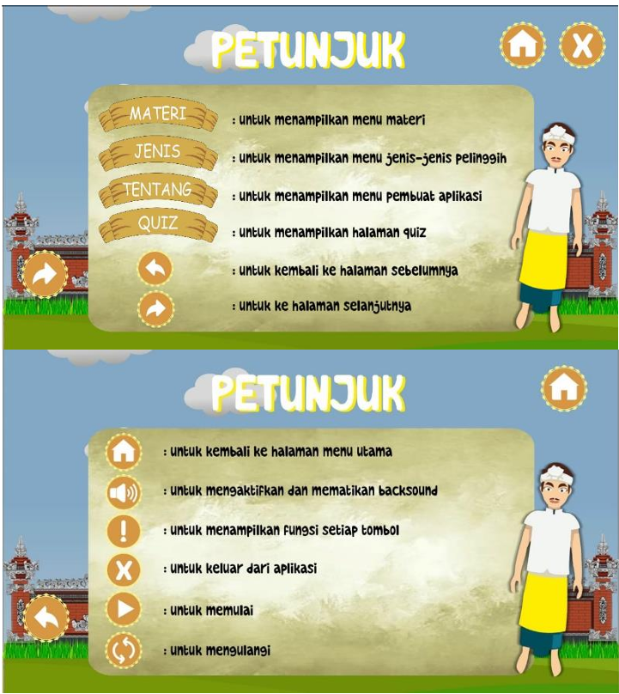 | Display instructions using learning media

After successfully visualizing the designed application, the next trial obtained good results. Based on the results of testing by content experts, media experts, and questionnaires to teenagers, an average score of 90% indicates that the interactive media for introducing the Family Sacred Place or Sanggah Merajan based on Android has met the established criteria, respondents consider this interactive learning media can quickly understand the form and function of each pelinggih, as well as develop better reading and writing skills.

CONCLUSION
The development of an interactive Android-based media platform for introducing family shrines, or sanggah merajan, has yielded quite positive results after undergoing a trial phase. In the future, this platform can be further developed by adding more material categories and more engaging features, making it a viable learning tool for ongoing use.

REFERENCES
[1] N. L. G. Leony Risdayanti and I. P. Windu Mertha Sujana, “Penguatan Nilai Karakter Disiplin Dan Demokratis Melalui Organisasi Sekaa Teruna Teruni Di Bali,” Widya Accarya, vol. 13, no. 1, pp. 101–105, 2022, doi: 10.46650/wa.13.1.1243.101-105.
[2] I. N. Ariyoga, “Peranan Organisasi Sekaa Teruna Teruni Sebagai Media Komunikasi Kepemudaan Hindu,” in Sekaa Teruna Teruni Organization, Hindu Youth communication media, 2020, pp. 113–121.
[3] I. P. P. Suryadana, I. W. Mudra, and I. N. Suardina, “Kajian Bentuk, Filosofi Ornamen dan Konstruksi Sanggah Rong Tiga Hindu di Bali,” Hast. J. Kriya Dan Ind. Kreat., vol. 1, no. 01, pp. 8–17, 2021, doi: 10.59997/hastagina.v1i01.68.
[4] I. G. Bayu, D. Permana, I. N. Anom, and F. Setiawan, “GRAPHIC DESIGN LEARNING INNOVATION : MOBILE INTERACTIVE MULTIMEDIA AT SMK PGRI 3 BADUNG,” vol. 3, no. December, pp. 457–462, 2024.
[5] I. N. A. S. P. Zunan Setiawan, I Made Pustikayasa, I Nyoman Jayanegara, I Nyoman Anom Fajaraditya Setiawan et al., Pendidikan multimedia. 2023.
[6] D. Mamis, Subria, DASAR-DASAR DESAIN KOMUNIKASI VISUAL (DKV). 2023. [Online]. Available: www.buku.sonpedia.com
[7] I. Yasa, I. N. Jayanegara, and ..., “Implementasi Pembangunan Berkelanjutan Melalui Perancangan Game Pengenalan Bahasa Bali Bagi Anak-Anak,” Pros. Semin. Nas. Desain dan Arsit., vol. 3, pp. 240–245, 2020, [Online]. Available: https://eprosiding.idbbali.ac.id/index.php/senada/article/view/311
[8] A. N. Latifah and R. Agustina, “Pengembangan Multimedia Interaktif Berbasis Komputer dalam Meningkatkan Hasil Belajar Kognitif di Sekolah Dasar,” Prim. J. Prim. Educ. Res., vol. 2, no. 1, pp. 120–134, 2024, [Online]. Available: https://journal.unu-jogja.ac.id/pgsd
[9] I. P. Gede, A. Putra, R. Aurelius, N. Diaz, and I. K. W. Adnyana, “Multimedia Interaktif Pengenalan Pura Dalem Blanjong Banjar Ceramcam , Kelurahan Kesiman Berbasis Android,” vol. 2, no. 1, pp. 331–336, 2025.
[10] L. Yasa, I. W. A. P., Putra, R. W., Kurniawan, H., Ruslan, A., Muhdaliha, B., Suryani, R. I., ... & Judijanto, Desain Komunikasi Visual: Teori dan Perkembangannya. 2024.

